A Technical Review of Quadcopter Firmware Design

Index

I. Introduction 2

II. Overview of Quadcopter Hardware and Control 2

III. Quadcopter Models 3

IV. Firmware Design 4

V. Sensors 6

VI. Actuators (Motors) 6

VII. Communication Mechanisms 7

# Introduction

The goal of this report is to examine the design of firmware used in quadcopters based on my experience of reading papers on the topic, the theory covered in lectures, as well as other research that I have conducted. I will be conducting the review on details related to sensors, actuators, and communication mechanisms that the firmware is controlling.

# Overview of Quadcopter Hardware and Control

As the name suggests, a quadcopter is a helicopter that has four motors. It is a small, unmanned aerial vehicle (UAV), commonly referred to as a drone. The four motors enable it to fly; two motors turn clockwise, the other two turn anti-clockwise. To help keep the quadcopter airborne, there are also two sets of propellers. Quadcopters can be controlled from the ground, using either specialised radio or Wi-Fi controllers, or simple, smart devices like smartphones or tablets. They can move in three dimensions, as introduced by Leonhard Euler in his work on angles to describe the orientation of a rigid body with respect to a fixed coordinate system. These are:

1. Yaw, nose left or right about an axis running up and down;
2. Pitch, nose up or down about an axis running from wing to wing;
3. Roll, rotation about an axis running from nose to tail.

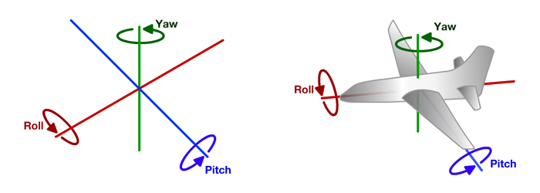

Figure 1 – Roll, Pitch, Yaw

Drone technology has a multitude of useful operations. As a hobby, they can be used for aerial photography, or to track animals when hunting. With attached cameras and sensors, quadcopters can carry out land surveys, air quality tests, and 3D modelling of a geographic location. They are useful for rescue teams when responding to emergencies as they can provide a better view of a dangerous situation, such as flying over cliff tops, in hostage situations where a human would be in the line of fire, or to search for and locate bombs.

Farmers and agricultural companies can use drones to easily and quickly monitor their farmland and animals remotely. With the rise of hobbyist and professional drone use, national aviation authorities have communicated European Union Regulation guidelines to drone operators. Such rules include needing to register as a drone user over certain criteria, as well as training and safety advice.

# Quadcopter Models

There are many different types of quadcopters designed and built by companies, offering a range of drones to suit varying levels of features and budget constraints. A high-end model such as DJI’s Phantom 4 Pro V2.0 is priced at €1,700, whereas the modest Eachine H8 Mini can be purchased for €20.

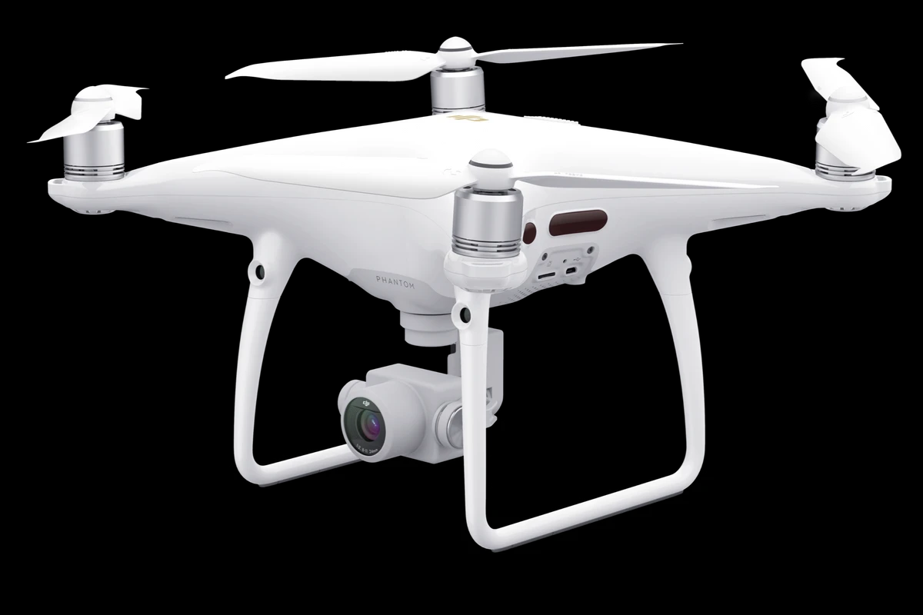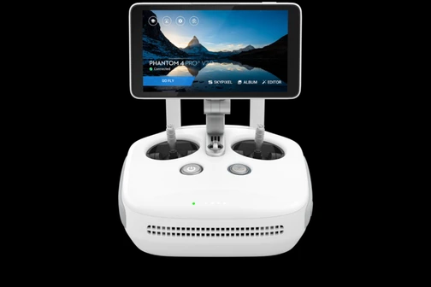

Figure 2 – Phantom 4 Pro V2.0 and Controller

One of the best-selling drone suppliers at the moment is DJI (Da-Jiang Innovations), a Chinese-based technology company. Within its range, the well-known Phantom series is now on its fourth generation. Designed for the professional creator, the Phantom 4 Pro V2.0 can shoot 4K video at 60fps, taking 20MP photos, thanks to its 1-inch CMOS (Complementary Metal Oxide Semiconductor) sensor. With five directions of optical sensing, it provides additional safety, making flying easier for the operator. The on-board gimbal camera has an optimised f/2.8 wide-angle lens, an enhanced video processing system that enables recording in D-Log mode with the use of H.265 codec, and also boasts a precise mechanical shutter. All of these features capture professional footage, optimising image quality, while eliminating rolling shutter distortion. The drone has a max speed of 72km/h (45mph), with a battery providing 30 minutes of flight time.

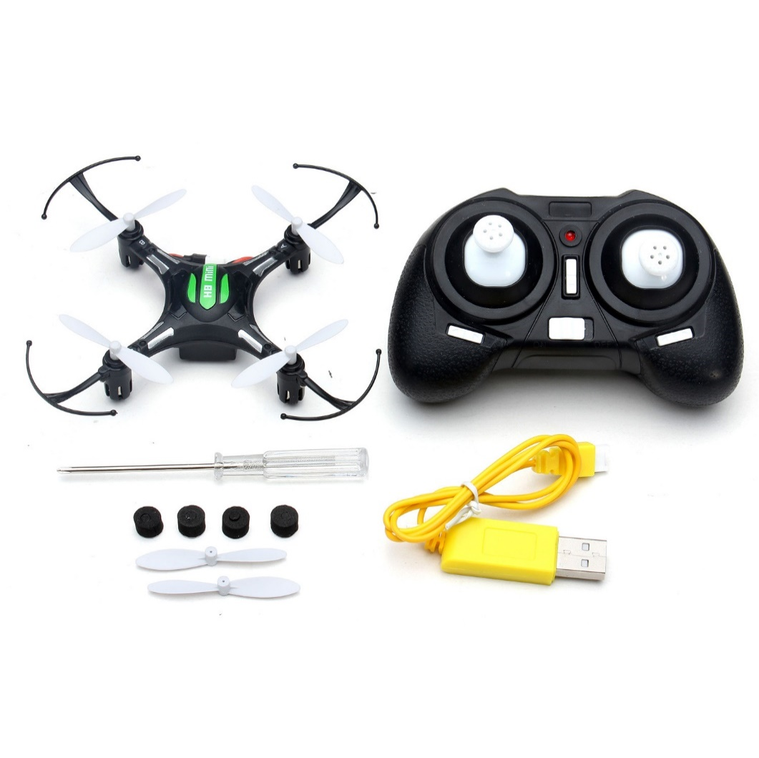

Figure 3 – Eachine H8 Mini and Controller

A much less expensive kit, the Eachine H8 Mini RC Quadcopter is suitable for those who are beginning their forage into the UAV realm. It has a flying time of 5-7 minutes, a 45-minute recharge time, and can fly up to a distance of 30 metres. The remote control has an auto-return button, making it easier for the quadcopter to find the way home, a useful feature for new drone operators who are not yet familiar with the remote controls and flying angles. With a 6-axis gyro and a lightweight airframe, it provides stable flying and easy control. Utilising its four LEDs, the device can perform 3D tumbling in four directions, a post-processing technique for smoothing and polishing the surfaces of objects in a fully automated process. Powered by an ARM Cortex-M3 processor, the H8 Mini allows the use of open-source firmware, encouraging customers to enhance their technical and software development skills.

# Firmware Design

Firmware is a set of instructions programmed on a device that permanently resides within the hardware. Typically stored in a device’s flash ROM (read-only memory), it sends instructions to other devices in order to perform tasks. Firmware can be erased and rewritten, meaning that companies can provide firmware updates for their hardware, even long after they have been sold. It is important that installed firmware is updated for bug fixes and improvement. Open-source firmware projects for unmanned quadcopters include PX4, ArduPilot, and Silverware. The brain of a drone is called an autopilot. It consists of flight stack software running on vehicle controller hardware.

According to its website, “PX4 is an open source flight control software for drones and other unmanned vehicles. The project provides a flexible set of tools for drone developers to share technologies to create tailored solutions for drone applications. PX4 is hosted by Dronecode, a Linux Foundation non-profit.” The code is free to use and modify, which is ideal for those who want to learn how to hack quadcopters. Its global community can be relied upon when attempting to fix bugs, guiding users who need assistance from a mentor.

PX4 blends sensor output with information from other positional sources, such as GPS, to provide a more accurate position lock. It is a highly modularised flight stack, where each flight function runs in separate threads. It builds on the current NuttX and PX4 firmware development efforts. It boasts flexible and powerful flight modes, as well as safety features, and is a good choice of hardware for sensors and other peripherals. PX4 is also capable of running on simulated platforms, such as FlightGear, jMAVSim, and AirSim. All simulators communicate with PX4 using the Simulator MAVLink API. This API defines a set of MAVLink messages that supply sensor data from the simulated world to PX4, returning motor and actuator values from the flight code that will be applied to the simulated vehicle. A serial connection is used to connect Joystick/Gamepad hardware via QGroundControl.

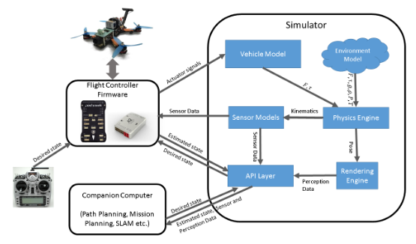

Figure 4 – AirSim Simulation Architecture

AirSim is a high-fidelity visual and physical simulation for autonomous drones. Due to its realistic simulations, it is resource intensive, requiring a relatively powerful computer to run. It was developed to train various robotics systems, allowing the AI to learn useful behaviours before being deployed to actual hardware. It is more cost-effective when compared to training AI using exclusively hardware, which will potentially become broken in the early learning stages. The simulation can create a read world full of realistic buildings, trees, roads, houses, all the while rendering shadows and reflections. Impressively, it can simulate Earth’s environment, including gravity, air density, air pressure, and the planet’s magnetic field.

In the case of quadcopters, the operator may specify desired pitch, roll and yaw angles, and, using these, the PX4 flight controller can use sensor data from the accelerometer and gyroscope to estimate the current angles. It can then compute motor signals to achieve the desired angles. AirSim provides the sensor data from the simulated world to the flight controller. The flight controller outputs the actuator signals, which in turn is taken as input by the vehicle model component of the simulator.

ArduPilot is a flight control that runs as one large program on top of NuttX and the PX4 firmware. The reason for this is legacy considerations. The ArduPilot flight stack can also be compiled for older integrated flight computers. In addition, it has a huge code base that supports casual and light commercial flying very well.

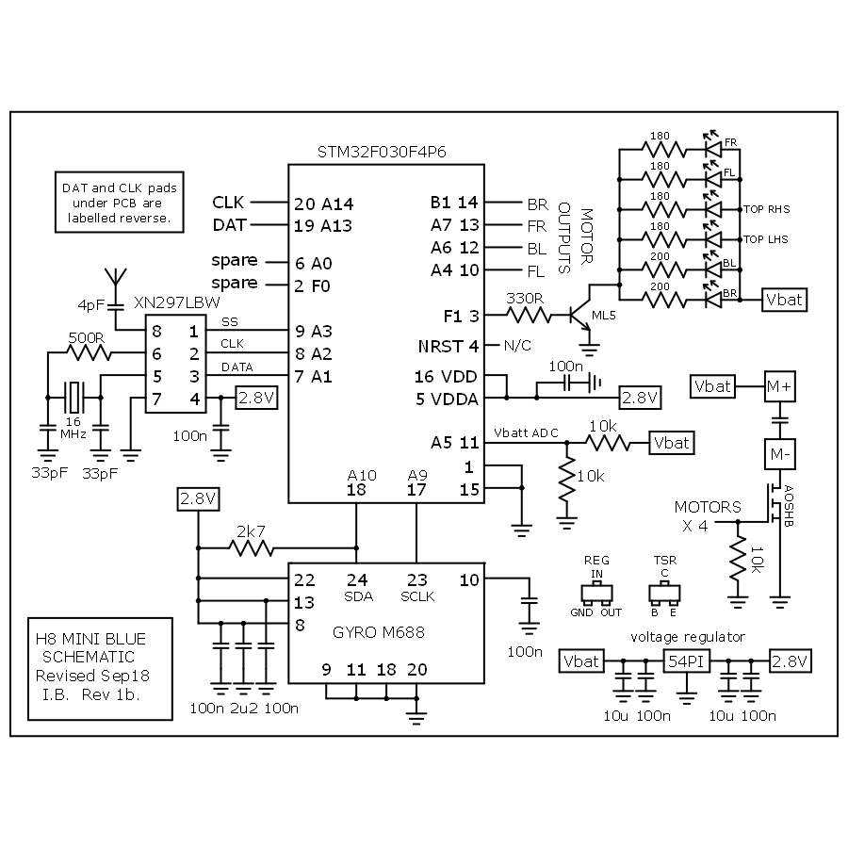

Figure 5 – H8 Mini Schematic

Silverware, a firmware initially developed by the registered user [silverxxx](https://www.rcgroups.com/forums/member.php?u=524557) on the online forum RCGroups.com in 2015, is compatible with many Eachine quadcopters, though not all. Its creation was due in part to the H8 Mini, as it was one of the first readily available, cheap quadcopter toys that could easily be hacked to use Acro mode. However, as noted on the Silverware wiki, most H8 Mini are considered to be no longer flashable. Throughout the years, the construction of the board has undergone changes, at times using completely different hardware, meaning that the firmware is not always guaranteed to work with a specific model of quadcopter.

One of Silverware’s most useful features is Acro mode, a difficult flight mode to master. It makes the justification that learning this flight mode on a cheaper piece of hardware is beneficial, rather than crashing continuously, leading to potentially breaking a more expensive quadcopter. Part of ArduPilot, Acro mode utilises the remote control joysticks to control the angular velocity of the quadcopter in each axis. It is used for performing aerobatics, such as flips and rolls. Silverware’s default radio protocol is Bayang, which allows the use of telemetry on supported transmitters. This firmware has also implemented gesture commands communicated via joystick sequences. For example, the gesture *Left - Left - Down* would enable Acro mode.

# Sensors

Quadcopters use many sensors to avail of their various features. These include an accelerometer, barometer, gyroscope, GPS, inertial measurement unit (IMU), and a compass, among others.

An accelerometer is used to measure acceleration forces acting on a quadcopter in order to determine its position and orientation while in flight. There are two types of acceleration forces: static forces and dynamic forces. Static forces are forces that are constantly being applied to the object, such or gravity. Dynamic forces are “moving” forces applied to the object at various rates, such as vibration.

A barometer is used to measure pressure. In a flying device, this is useful for measuring altitude. The drone can calculate how high above the ground it is by sensing the changes in air pressure, allowing the device to calculate its own height.

A gyroscope is used to measure angular acceleration (on the x, y, z axis). It helps the quadcopter to fly in a stable line. Distance sensors are used for precision landing, object avoidance, and terrain following.

A compass is used to determine cardinal direction.

GPS is used to track location. A GPS receiver in the quadcopter listens out for signals that are constantly being sent by navigation satellites orbiting Earth. The receiver then calculates the distance from four or more of these satellites, enabling it to pinpoint the device’s location. This is useful for the auto-return home feature on quadcopters, such as that in the H8 Mini. Knowing the drone’s location, you can set specific coordinates for the it to fly back to. This can also be used to map out a route for more autonomous drones.

An IMU is a small board that contains the gyroscope and the accelerometer. These are essential as drones become more autonomous as they, along with GPS, are critical for maintaining direction and flight paths. An IMU senses changes in direction, which it then relays to the CPU, outputting direction, orientation, and speed.

# Actuators (Motors)

PX4 uses outputs to control motor speed, flight surfaces like ailerons and flaps, camera triggers, parachutes, grippers, and many other types of payloads. The outputs are divided into MAIN and AUX outputs, and individually numbered (i.e. MAINn and AUXn, where n is 1 to usually 6 or 8).

Typically, the MAIN port is used for core flight controls while AUX is used for non-critical actuators/payloads. The actual ports/bus used for the outputs on the flight controller depends on the hardware and PX4 configuration. Some boards may utilise FMU PWM OUT or IO PWM Out, for example.

Many PX4 drones use brushless motors that are driven by the flight controller via an Electronic Speed Controller (ESC). The PWM ESC converts a signal from the flight controller to an appropriate level of power delivered to the motor. On every ESC, there is firmware that determines its performance, which protocols are supported, and which configuration interface can be used. There are different types of firmware available, as it is hardware dependent. ESC protocols are analogue signals, and are synced to the PID loop to reduce jitters, improve performance, and reduce delay between stick inputs and the reaction of the drone. Some ESCs require a low value pulse before switching on as a safety feature to protect users who have the throttle stick in the middle position while powering on. After powering on, if a signal has not been received, some ESCs have implemented a timeout feature to prevent motor activation.

# Communication Mechanisms

To manually control a quadcopter, a radio control (RC) system is used. These typically consist of joystick throttles, switches, buttons, and perhaps a screen. The remote control uses a transmitter to communicate control instructions to a receiver on the quadcopter. The physical controls are used to move the drone, such as changes in yaw, pitch, and roll, as well as controlling speed and direction. On telemetry-enabled RC systems, the remote control can also receive and display information from the drone, such as battery level.

A telemetry radio provides a wireless Micro Air Vehicle Link (MAVLink) connection, which is a very lightweight, header-only message marshalling library for micro air vehicles. This makes it possible to tune parameters while a vehicle is in flight, and to inspect telemetry in real-time. Telemetry data can be stored in flight logs saved onto an SD memory card inserted into the drone, to be collected and later visualised and analysed. This can allow the user to generate heat maps, 3D renders of geographic locations, or track weather changes. In the case that sensor values must be reliably correlated to an exact location and specific time, then data pertaining to the sensor can be sent with GPS coordinates and accurate timestamps.

As with any radio, the support of channels is important, the number of which defines how many different physical controls on the remote control can be used to send commands to the drone. At least 4 channels must be supported to account for roll, pitch, yaw, and thrust. Ground vehicles need at least two channels for steering and throttle.

Newer quadcopters can be controlled via Wi-Fi or Bluetooth by using a supported Android smartphone or tablet. Despite this, higher-end drones still rely on a dedicated remote controller for actual flight controls to aid better precision.